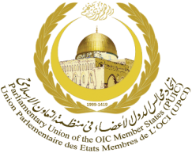
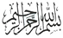
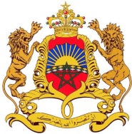
Kingdom of Morocco
Parliament

14th SESSION OF THE PUIC CONFERENCE

AND OTHER RELATED MEETINGS

11-14 march 2019,
RABAT – KINGDOM OF MOROCCO

HOTEL RESERVATION FORM
ONOMO Rabat Terminus Hotel
Address : 286, avenue Mohammed V, Rabat – Maroc
Contact : Jalila OUKSSIH
T : (+212) 5 37 21 29 00 |
M : (+212) 6 61 25 26 07
Reservation : terminus@onomohotel.com
www.onomohotel.com
Booking before February 10th, 2019
[One form per participant]
COUNTRY

Ms. Mr.
FAMILY NAME |  | FIRST NAME
Address
City |  |  | Country
Telephone |  |  | Mobile

Date of arrival |  | Flight No. | Time of arrival
Date of departure |  | Flight No. | Time of departure
Type of room

Credit card: |  | Visa Master Card American Express Diners
Name of credit card holder:
Credit card number: |  |  |  |  | Expiry Date:
DATE |  |  | SIGNATURE

Kindly return this form to this address: terminus@onomohotel.com

With a copy to:
KINGDOM OF MOROCCO | General Secretariat of PUIC
Adresse : Parliament, Avenue Mohammed V B.P. 431, Rabat | Address: P.O. Box :19395- 3851 Tehran, Iran
Tél: + 212 5 37 67 96 01/ 02 / 03 / 04  :+212 537 21 83 39 | Tél. : (9821) 22418860 / 61 / 62
Fax : + 212 5 37 76 03 90  :+212 537 73 05 68 | Fax : (9821) 22418858/59
E-mail : puic14@parlement.ma | E-mail : g.s@puic.org

